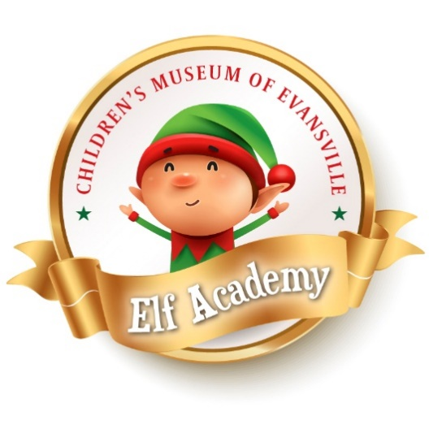
Elf Academy is THE holiday event of the year, allowing families and children to explore the magic of the winter season through interactive activity stations allowing them to earn their Honorary Elf status. Elf Academy is an annual fundraiser that allows cMoe to continue to advance our mission of creating extraordinary experiences that ignite the imaginations of children and families through the power of play.

Saturday December 9, 2023
10:00 a.m. – 2:00 p.m.
Children’s Museum of Evansville
Event Highlights:
20,000 square feet of holiday magic filled with activities and special guests along the way
Snowball Toss | Dance Party | Wood Crafting
Magic Mountain Slide | Sock Skating | Art Stations
Elf Games | Holiday Village Vendors | Holiday Science
Letters to Santa | Professional Photos with Santa & Mrs. Claus | Breakfast

Elf Academy Sponsorship Opportunities
Tree Topper ($5,000) – Co-Presenter w/Old National Bank
- Prime name/logo recognition beneath cMoe logo on all event materials
- Sponsorship recognition on cMoe’s website, newsletter and social media
- Social media stand-alone post with logo recognition
- Signage, recognition in event guide, and verbal acknowledgement during the event
- Eight (8) event tickets for guests of choice with breakfast included
- Eight (8) event tickets donated to nonprofits serving families in need
- First in line with Santa & Mrs. Claus

Toy Workshop Sponsor ($3,000)
- Logo inclusion within Toy Workshop area
- Sponsorship recognition on cMoe’s website, newsletter and social media
- Social media stand-alone post with logo recognition
- Signage and recognition within the event guide during the event
- Eight (8) event tickets for guests of choice with breakfast included
- Four (4) event tickets donated to nonprofits serving families in need

North Pole Village Sponsor ($1,500)
- Logo inclusion within North Pole Village
- Signage and recognition within the event guide during the event
- Eight (8) event tickets for guests of choice with breakfast included
- Two (2) event tickets donated to nonprofits serving families in need

Candy Cane Sponsor ($800)
- Signage and recognition within the event guide during the event
- Eight (8) event tickets for guests of choice with breakfast included

Secret Santa ($255)
- Annual membership for family in need
- Four (4) event tickets with breakfast included for a family in need

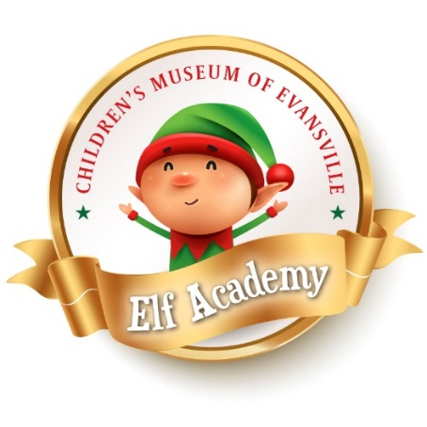
Sponsorship Pledge Form

Contact Information:
Company/Organization/Individual: _____________________________________
Primary Contact Name: ________________________________________
Title: _______________________________________________________
Phone: _____________________________________________________
Email: ______________________________________________________
Organization Address: _________________________________________
City/State/Zip: ________________________________________________
Corporate Sponsorship Level:
Tree Topper Sponsor ($5,000) Toy Workshop Sponsor ($3,000)
North Pole Village Sponsor ($1,500) Candy Cane Sponsor ($800)
Secret Santa Sponsor ($255)
Payment Options:
Please send an invoice for $ _ to: _________________________________
Enclosed is my check for $ made payable to the Children’s Museum of Evansville

Signature: ______________________________________________Date:__________________
To ensure that each Sponsor receives full associated benefits, we ask that you kindly commit by September 1st. Please include your logo (vector image or PNG file) when returning via email. Questions? Please contact us at 812-643-2663 and ask for the Executive Director.
Please return Sponsorship Form to Children’s Museum of Evansville. P.O. Box 122 Evansville, IN 47701 or sterry@cmoekids.org
***I AM UNABLE TO COMMIT TO A CORPORATE SPONSORSHIP LEVEL
Enclosed is a donation in the amount of $_____________.

Thank you for your support of cMoe and Elf Academy 2023!

